Iterative set intersection for finding shortest path between users in social networks

Suraj Waghulde
Surajw@yahoo-inc.com

ABSTRACT

A social network is a network where users (nodes) are connected to each other by friendship (edges) or by some business interactions like linkedin. The edges are undirected and the out-degree of a user indicates the number of friends a user has. To find path between any two users (nodes) in the social network is computationally intensive. There are various algorithms in current research which are used to find a solution to this problem but these do not finish in realistic time. All these algorithms consider single source solution when we always have both the nodes to find the path for most of the social networking applications. In this paper we propose iterative set intersection technique for finding a shortest path between any two users in social networks. We use this algorithm to find higher level mutual connections in social networks in real time. We propose social networking applications which can be boosted using mutual connections data.

Keywords
Social Networks, mutual connections, graph algorithm, finding path, map reduce, social distance, people search, friend recommendation, targeted ads, targeted deals.

1. INTRODUCTION
There are various algorithms in current research for finding path between users in social networks. We are listing some of them which are tried in practice but are failing to give results which can be utilized by social networks to boost their applications.

- Transitive closure (deterministic but not realistic)
- Co-ordinate based distance (non-deterministic)

The solution using transitive closure is deterministic; it will surely lead to the shortest path and will find all the paths between any two users but considering the volume of users in social networks and their connections to each other it is not scalable solution. Biased random walk is non-deterministic solution which can not guarantee to find the path even if it exists and can lead to false data.

All these current algorithms are single source while in social network applications we know both the users. I want to use this information and propose an algorithm which can solve the problem of finding path between these users in real time.

2. ALGORITHM BASICS

We can apply the following fundamentals to help reduce the computationally intensive problem of finding path in social network to simple set intersection.

- Finding intersection of two sorted collections is linear in time.
- To find mutual connections or second degree path with one intermediate node between any two users on the social graph, we need to find intersection of direct connections of both the users.

Node1 Connections
Node2 Connections
A

Node1 -> A -> Node2

We wrote map reduce programs to extract and store the direct connections in sorted order from all the users on profiles.yahoo.com. To find path between any two users in the social network, we take intersection of these sorted connections. The time complexity to find the mutual connections through intersection is O(N) where N stands for out-degree of a node (number of friends of a user). However the space required for storing all the direct connections in sorted order is M*N where M is number of nodes in social network and N is out-degree of a node. We take advantage of space on the grid and find the mutual connections in real time.

3. ALGORITHM

store the connections in sorted order.
store connections connection in sorted order.
if user’s connection set contains the other user
list direct connection.
take intersection of the connections from both users.
if (set intersection not empty)
list the paths
if (set intersection of users connection’s connections with another users connections not empty)
take intersection of nodes in the intersection with the first user
list the paths
if (set intersection of users connections with another users connection’s connection not empty)
take intersection of nodes in the intersection with the second user
list the paths
if (set intersection of users connection’s connections with another users connection’s connection not empty)
take intersection of nodes in the intersection with the second user
list the paths
Continue taking iterative intersections to find higher degree of connectivity.

The first entry in the resulting list will be the shortest path. There can be multiple shortest paths. We can stop after finding the shortest path or we can continue finding paths between the users. All the paths listed in the list are in increasing order of social distance.

4. HIGHER DEGREE MUTUAL CONNECTIONS

In the later iterations of intersection we find paths with more than one user in between the two end users. As a result of which we get higher degree mutual connections between any two users. Let us consider the case of finding third level connectivity between any two users Node1 and Node2. We find all users A and B as shown in the diagram. Similarly we forth level of connectivity and list all users A, B and C on the path between user Node1 and Node2.

Time complexity of intersection of two unequal sorted sets is equal to the number of users in the larger set. We have maximum N^2 connections as input to the intersection for third and forth level connectivity where N stands for out-degree of a node. Time complexity of finding third and forth level connectivity is O(N^2).
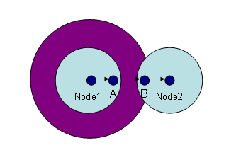

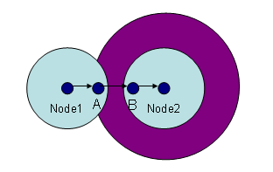

Node1 -> A -> B -> Node2

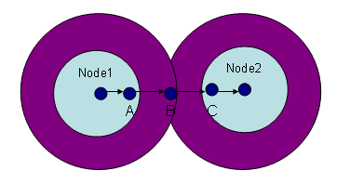
Node1 -> A -> B -> C -> Node2

5. OBSERVATION STATISTICS

We created more than 100 graphs with varying number of total connections in the graph. We came up with the following statistics for finding up to forth level of connectivity along with the shortest path. We list the reading we got running out implementation of the above technique.

Iterations | Number of connections | Average out-degree | Average time to find connections till level 4 | Average time to find mutual connections
50 | 20M | 100 | 13ms | 0.2ms
25 | 20M | 125 | 20ms | 0.4ms
25 | 25M | 25 | 1ms | 0.0ms
25 | 25M | 50 | 4ms | 0.1ms
25 | 10M | 100 | 10ms | 0.2ms
25 | 0.5M | 50 | 4ms | 0.1ms

6. OPTIMIZATION OF TECHNIQUE

Finding intersection of two sorted set can be easily parallelized or distributed. All the above findings were run on a single machine without multithreading or distributing the computation on multiple machines. We divide the input set in to smaller sets and distribute the computation over multiple nodes and combine the result using combiner or reducer in map reduce technology. Thus we can find the intersection of the large set extremely fast.

7. APPLICATIONS OF MUTUAL CONNECTIONS DATA
There are various applications of higher degree mutual connections in social networks. It already gives us a social distance between any two users on the social network. Facebook uses the mutual connections data for friend suggest for recommending friends. We can boost friend suggest application by adding higher degree of mutual connections. Linkedin uses it in showing through which other Linkedin users you can reach a particular person. We can rank people in people search based on number of mutual connections as a parameter.

Marketplace application on facebook uses mutual connections to show you advertisements of deals posted by your friend’s friend. We can further enhance this application to show advertisements of deals posted by higher level of connectivity. We find higher degree connections between individual’s profile and all the users posting the deals so that we get many more deals within level four trusted connections.

8. CONCLUSION

Iterative set intersection technique helped us to find shortest path in optimal time along with higher level connectivity between the users of social network. We took readings running our implementations and found that finding shortest path and calculating higher degree of mutual connections up to level four can be performed real time.

